**Create a Snapshot of a VM and Test it by loading the Previous Version/Cloned VM**

**AIM:**

To Create a Virtual Machine with 1 CPU, 2GB RAM and 15GB storage disk using a Type 2 Virtualization Software.

**PROCEDURE:**

**STEP 1:**

First install VMware workstation in your pc/laptop. Then open any of the created VM.then from taskbar ,in VM option select snapshot option.

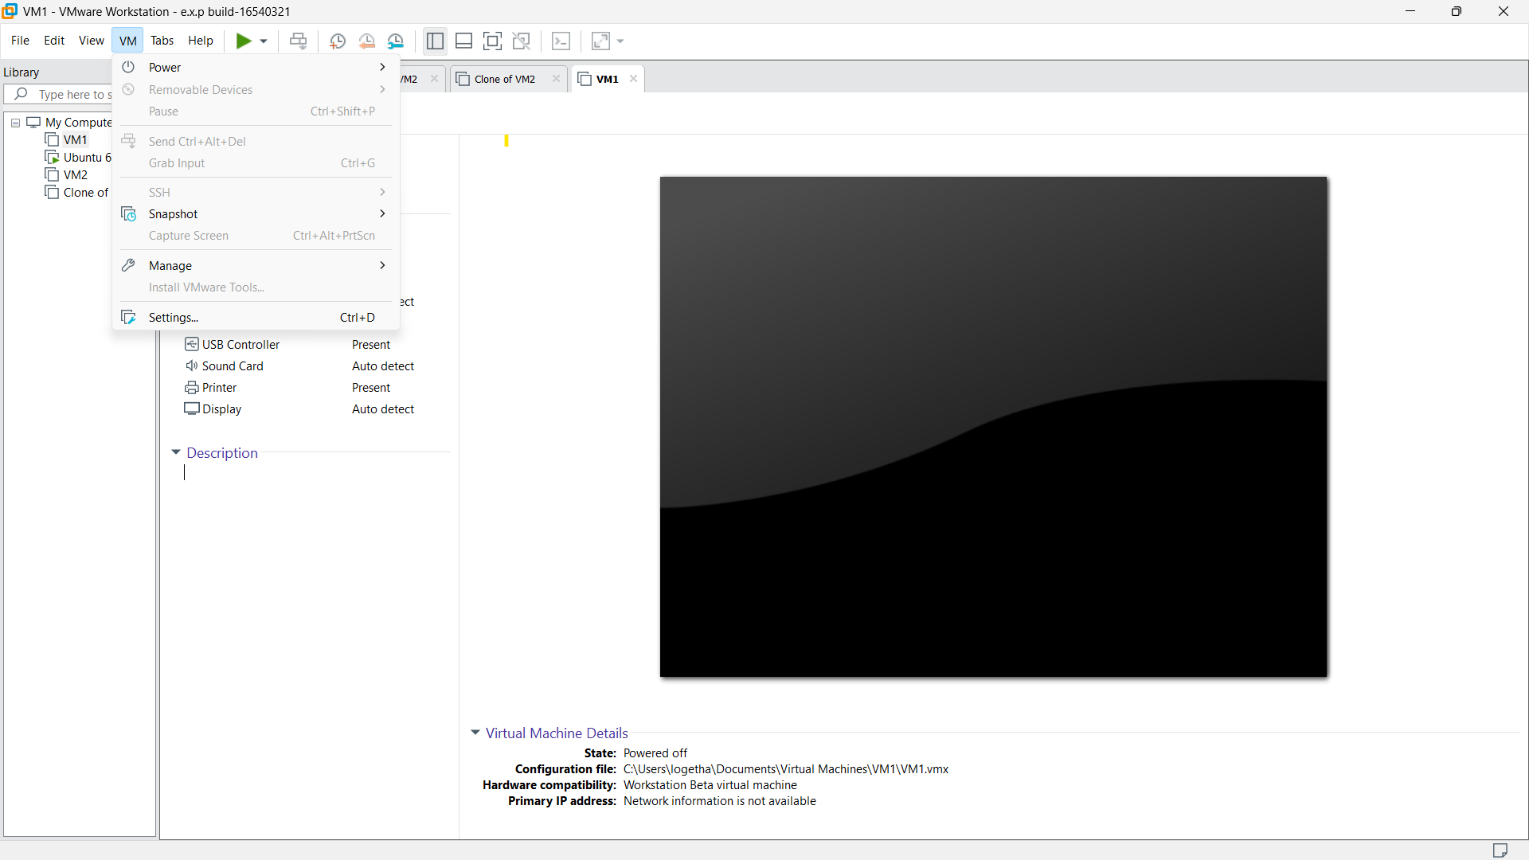

**STEP 2:**

Then take a snapshot.

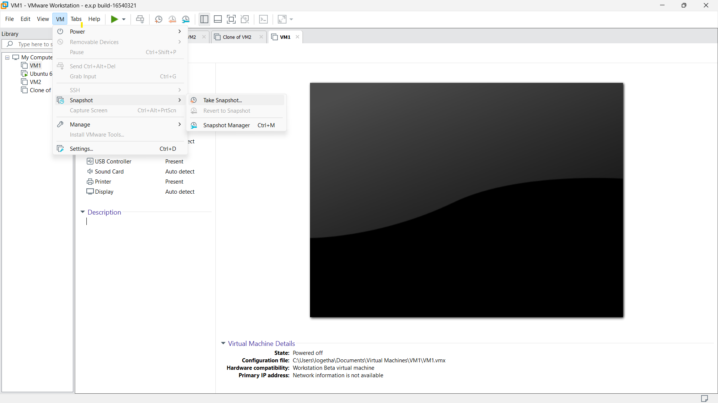

**STEP 3:**

Here,we can name the snapshot as we like.

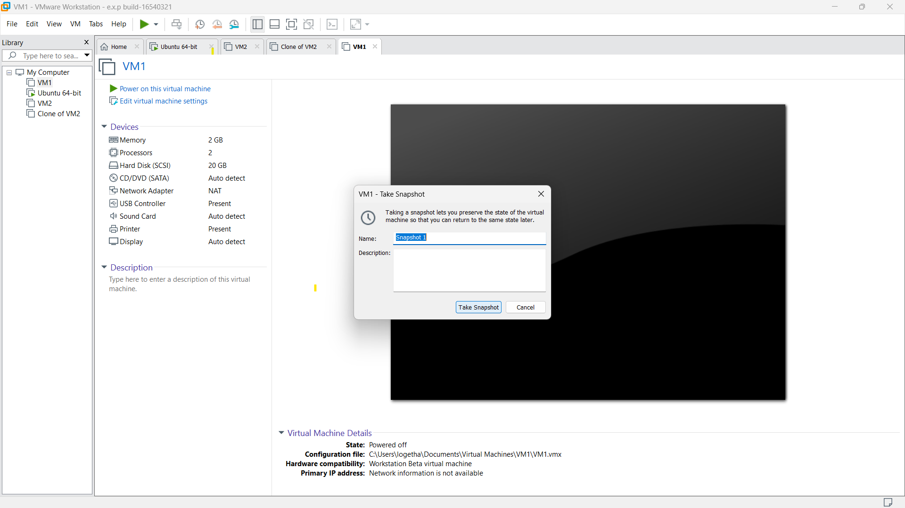.

**STEP 4:**

Then change any of the given specification and take another snapshot of the changes.

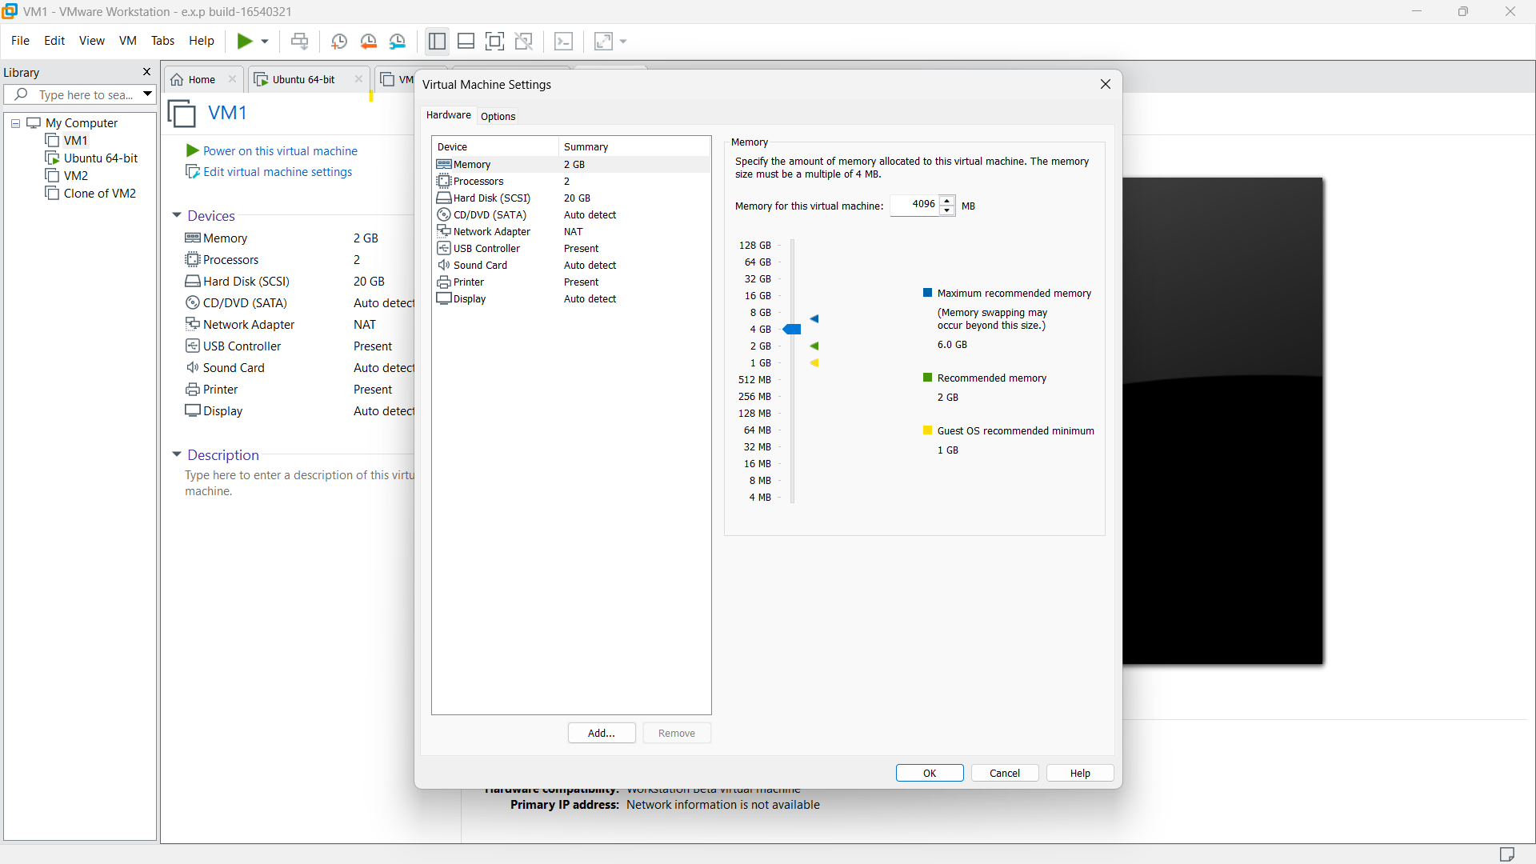

**STEP 5:**

then again change any of the specification and take another snapshot.

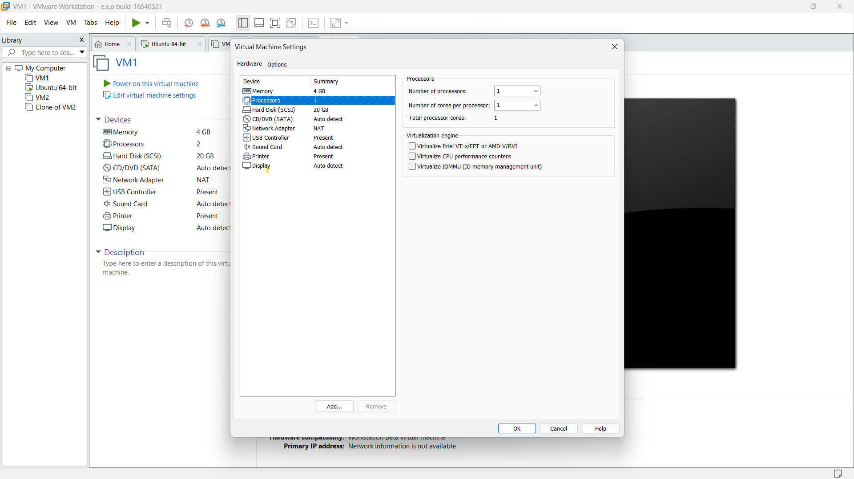

**STEP 6:**

then in the snapshot option select the snapshot manager option.

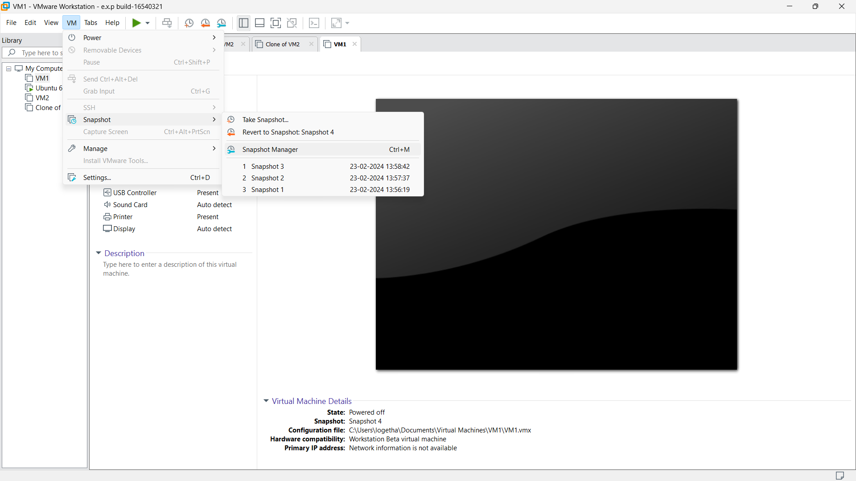

**STEP 7:**

No of snapshot taken will be displayed. We can select any of those snapshot to go back to that specific specification. So select any of the snapshot and click yes.

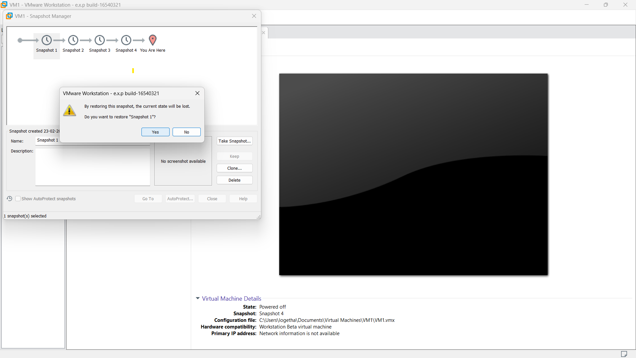

**STEP 8:**

Our VM will be displayed on the particular snapshot.

